Group 1 Project
Careermindr – Job Portal System

Team Members:
Neha K S
Mukesh Balaji.M.P
Vijay Athithyaa G V
Pranali Prakash Pisal

Company
Amdox Technologies
Tenure: 1 Month

Mentor : Shaurya Pandya
Date of Submission: 08-01-2026

Acknowledgment

We would like to express our sincere gratitude to Amdox Technologies for providing us with the Internship opportunity to work on this online remote project. This project has helped us gain valuable hands-on experience and practical exposure to real-world software development practices.

We extend our heartfelt thanks to our mentor Shaurya Pandya for their continuous guidance, encouragement, and constructive feedback throughout the project tenure. Their support and technical insights played a crucial role in the successful completion of this project.

Finally, we would like to acknowledge the efforts and cooperation of all our team members. The collaborative work, mutual support, and shared responsibility among the team were key factors in completing the project efficiently within the given time frame.

TABLE OF CONTENTS

CONTENTS | Page No
TITLE PAGE | i
ACKNOWLEDGMENT | ii
TABLE OF CONTENTS | iii
Abstract | 01
Introduction | 02
Objectives | 03
Functional Requirements | 04
System Architecture & Design | 06
Technology Stack | 08
Implementation Details | 10
Project Review & Output
- Functional Output | 12
- User Interface Output | 13
- System Performance & Reliability | 15
Conclusion | 17
Team Contributions | 18
References | 19

ABSTRACT

Careermindr is an intelligent, role-based job portal system developed as part of an online remote project under Amdox Technologies. The platform is designed to efficiently connect job seekers and employers through a secure and user-friendly web application. Employers can create and manage job listings, review applications, and update application statuses, while job seekers can browse available jobs, apply for positions, and track the progress of their applications. The system is built using a modular architecture with clearly separated service components for authentication, profile management, job listings, and job applications. Secure user authentication is implemented using JWT-based authorization, ensuring data privacy and role-based access control. The application provides separate dashboards for employers and job seekers, enabling effective management of job postings and applications. Careermindr focuses on scalability, maintainability, and clean system design, making it suitable for future enhancements such as advanced job recommendations and analytics. This project demonstrates practical implementation of full-stack development concepts and reflects real-world industry practices in building scalable web applications
.
INTRODUCTION

In today’s digital era, online job portals play a vital role in connecting employers with suitable job seekers in an efficient and scalable manner. With the growing demand for streamlined recruitment processes, organizations require platforms that allow them to manage job postings and applications effectively, while job seekers seek intuitive systems to discover and apply for relevant opportunities.
Careermindr – Intelligent Job Portal System is developed to address these needs by providing a secure, role-based web application that simplifies the recruitment workflow for both employers and job seekers. The system enables employers to post and manage job listings, review applications, and make hiring decisions, while job seekers can browse available jobs, submit applications, and track their application status through a dedicated dashboard.
The project follows a modular system design approach with clear separation of responsibilities across authentication, profile management, job listings, and application processing. This architecture improves maintainability, scalability, and ease of future enhancement. Secure authentication and role-based access control ensure that users can only access features relevant to their roles, enhancing data privacy and system reliability.
Developed as a one-month online remote project under Amdox Technologies, Careermindr provides practical exposure to full-stack web development and reflects real-world software engineering practices. The project emphasizes clean architecture, secure data handling, and user-focused design, making it suitable for both academic evaluation and industry-oriented learning.

OBJECTIVES

The primary objective of the Careermindr –Job Portal System is to design and develop a secure and user-friendly web application that efficiently connects job seekers with potential employers. The system aims to simplify the recruitment process while ensuring scalability, maintainability, and role-based access control.

Functional Objectives
- To provide secure user registration and login for both job seekers and employers.
- To enable employers to create, update, close, and manage job listings.
- To allow job seekers to browse available job opportunities and apply for suitable positions.
- To implement application tracking functionality for job seekers.
- To provide employers with tools to review applications and update application statuses.
- To support profile management for both user roles, including resume upload for job seekers.

Technical Objectives
- To implement secure authentication using JWT-based authorization.
- To enforce role-based access control to restrict features based on user roles.
- To design a modular backend architecture with clear separation of concerns.
- To ensure reliable data storage and retrieval using a relational database.
- To utilize asynchronous backend processing for improved performance.

FUNCTIONAL REQUIREMENTS

The Careermindr offers a comprehensive set of features designed to streamline the recruitment process for both job seekers and employers. The system provides secure access, role-based functionality, and an intuitive user experience.
1. User Authentication
- Secure user registration and login for job seekers and employers.
- JWT-based authentication to ensure secure access.
- Role-based access control to restrict features based on user roles.
2. Profile Management
- Job seekers can create and update personal profiles.
- Resume upload functionality for job seekers.
- Employers can manage company profiles with relevant details.
- Secure storage and retrieval of profile information.
3. Job Listing Management
- Employers can create, edit, close, and delete job listings.
- Job listings include details such as job title, description, qualifications, responsibilities, location, job type, and salary range.
- Employers can view and manage all their posted jobs through a dashboard.
4. Job Search and Browsing
- Job seekers can browse active job listings.
- Easy-to-navigate job browsing interface

5. Job Application Management
- Job seekers can apply for jobs directly through the portal.
- Duplicate application prevention ensures users cannot apply multiple times for the same job.
- Job seekers can track the status of their applications.
- Employers can review applications and update application statuses (Accepted/Rejected).
6. Role-Based Dashboards
- Separate dashboards for job seekers and employers.
- Job seekers can view applied jobs and application status summaries.
- Employers can monitor job postings, application counts, and recent applications.

SYSTEM ARCHITECTURE & DESIGN

The application is built as a full-stack web system consisting of three main layers:
- Presentation Layer (Frontend):
Provides user interaction through server-rendered web pages and client-side JavaScript. This layer handles user inputs, page navigation, and dynamic content rendering.
- Application Layer (Backend Services):
Implements the core business logic using FastAPI. The backend is organized into separate service modules for authentication, profile management, job listings, and job applications.
- Data Layer (Database):
Uses a relational database to store user credentials, profiles, job listings, and application data in a structured and secure manner.

Modular Service Design
The backend is divided into independent service modules, each responsible for a specific domain:
- Authentication Service: Manages user login, registration, JWT generation, and role-based access control.
- Profile Service: Handles job seeker and employer profile management, including resume uploads.
- Job Listing Service: Manages job creation, modification, and browsing of active listings.
- Application Service: Processes job applications, prevents duplicates, and manages application status updates.
Each service follows a layered structure with dedicated models, schemas, service logic, and routing, ensuring minimal coupling between components

Role-Based Access Control
The system enforces role-based access control to ensure that:
- Employers can manage job listings and review applications.
- Job seekers can browse jobs, apply, and track application status.
Unauthorized access to restricted resources is prevented through backend validation.
Request Flow
- The user interacts with the frontend interface.
- Requests are sent to the backend through HTTP endpoints.
- Backend services process requests after authentication and authorization checks.
- Data is retrieved or stored in the database.
- Responses are sent back to the frontend for display.
Design Benefits
- Improved scalability due to modular service separation.
- Easier maintenance and future enhancements.
- Secure handling of user roles and sensitive data.
- Clear and organized codebase aligned with industry best practices.

TECHNOLOGY STACK

Frontend Technologies
- HTML5 – Used for structuring web pages and forms.
- CSS3 – Used for styling the user interface and ensuring a consistent design across pages.
- JavaScript (Vanilla JS) – Used for handling client-side interactions, API calls, and dynamic content updates.
- Jinja2 Templates – Used for server-side rendering of dynamic web pages.
Backend Technologies
- FastAPI – Used as the backend framework for building RESTful APIs and handling business logic.
- Python – Core programming language used for backend development.
- Uvicorn – ASGI server used to run the FastAPI application efficiently.
- SQLAlchemy (Async ORM) – Used for database interaction and object-relational mapping.
- asyncpg – PostgreSQL asynchronous database driver.
Database
- PostgreSQL – Relational database used to store user information, job listings, profiles, and application data securely.
Authentication & Security
- JWT (JSON Web Tokens) – Used for secure user authentication and authorization.
- Role-Based Access Control (RBAC) – Ensures access to features based on user roles.
- HTTP-only Cookies – Used to securely store authentication tokens.

Development & Tools
- Visual Studio Code – Code editor used for development.
- Python Virtual Environment (venv) – Used for dependency management.
- Git & GitHub – Used for version control and team collaboration.
- python-dotenv – Used for environment variable management.

IMPLEMENTATION DETAILS

1. User Authentication Module
- Implemented secure user registration and login using JWT-based authentication.
- Passwords are securely stored using hashing techniques.
- Role-based access control ensures that users can access only authorized features.
- HTTP-only cookies are used to prevent unauthorized access and improve security.
2. Profile Management Module
- Job seekers can create and update profiles containing personal details, contact information, and resume uploads.
- Employers can maintain company profiles including organization details and contact information.
- Profile data is stored in a relational database and retrieved dynamically.
3. Job Listing Module
- Employers can create, edit, and delete job listings.
- Each job listing contains job title, description, required qualifications, responsibilities, location, and salary range.
- Job listings are stored in the database and displayed dynamically to job seekers.
4. Job Search Module
- Job seekers can search for jobs using keywords.
- Basic filters such as job type and location are implemented to narrow down search results.
- Search operations are optimized using indexed database queries.

5. Job Application Module
- Job seekers can apply for jobs directly through the portal.
- Each application is linked to both the job seeker and the job listing.
- Employers can view submitted applications and manage candidate status.
- Application status updates are reflected in real-time on user dashboards.
6. Dashboard Module
- Separate dashboards are provided for job seekers and employers.
- Job seekers can track applied jobs and update profiles.
- Employers can manage job postings and review applications.
- Dashboard data is fetched dynamically through REST APIs.
7. Database Implementation
- PostgreSQL is used as the primary database.
- SQLAlchemy ORM handles database operations.
- Tables are designed with proper relationships between users, jobs, and applications.
- Asynchronous database operations improve performance and scalability.
8. Error Handling & Validation
- Server-side validation ensures data integrity.
- Meaningful error messages are returned for invalid inputs or unauthorized actions.
- Exception handling is implemented across API layers.

PROJECT REVIEW & OUTPUT

This section evaluates the final implementation of the Careermindr –Job Portal System based on functionality, user experience, and system performance. It highlights how effectively the project objectives were achieved during the one-month development tenure.
1. Functional Output
The system successfully delivers all core functionalities as defined in the project requirements.
- Secure user registration and login for both job seekers and employers
- Role-based dashboards with restricted access
- Employers can create, update, and manage job listings
- Job seekers can search for jobs and apply directly through the portal
- Resume upload and profile management functionality
- Employers can view applications and track candidates
- Real-time application status updates displayed on dashboards
All modules were tested and integrated to ensure smooth interaction between frontend and backend components.
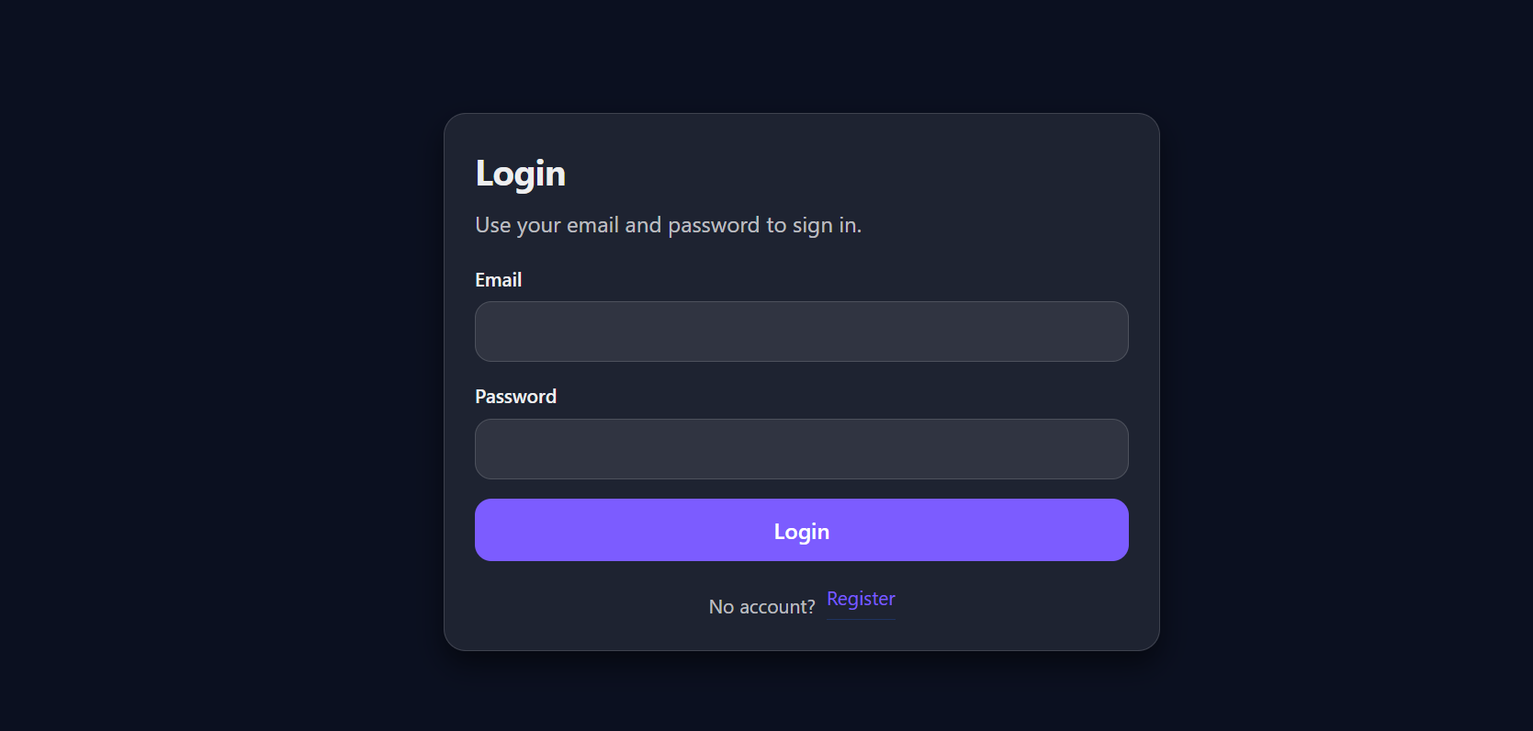

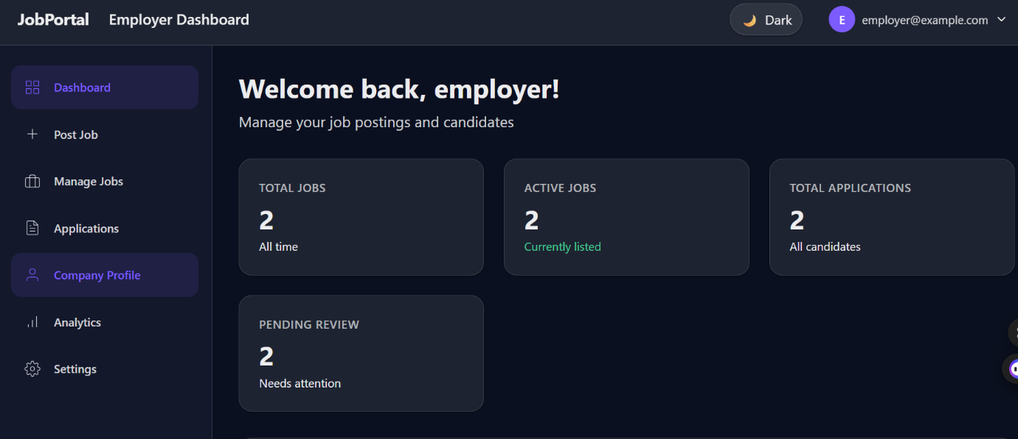
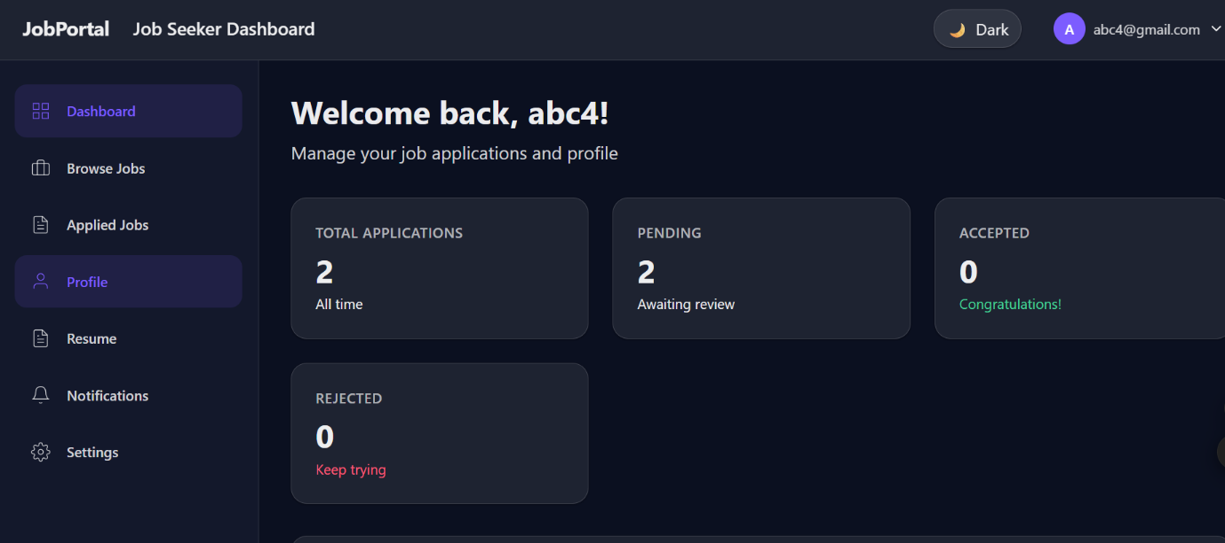

2. User Interface Output
The portal features a clean, minimal, and user-friendly interface designed to enhance usability.
- Simple navigation and clear page layouts
- Consistent color scheme and typography
- Easy-to-use forms for job posting and applications
- Responsive pages suitable for different screen sizes
- Dashboards display information in an organized manner

The UI design ensures that users with minimal technical knowledge can easily use the platform.
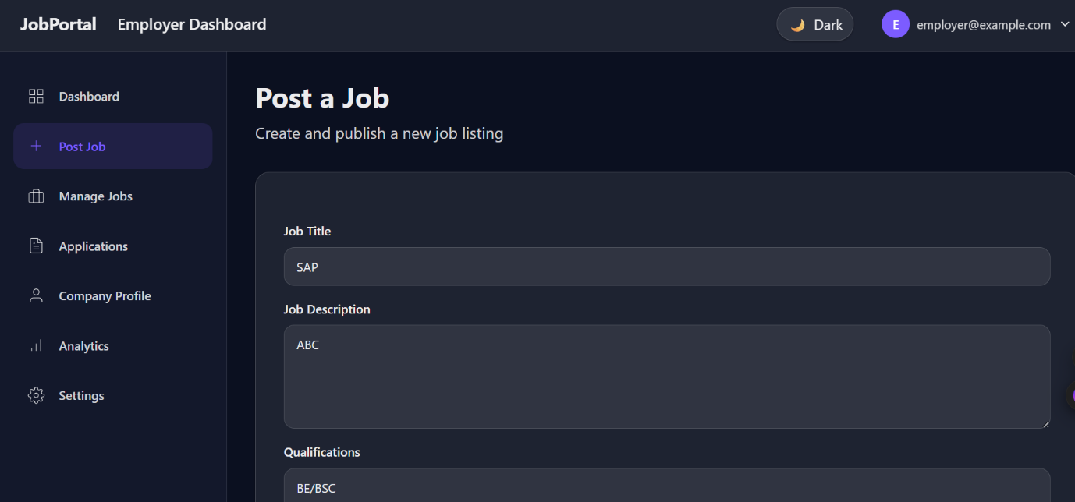
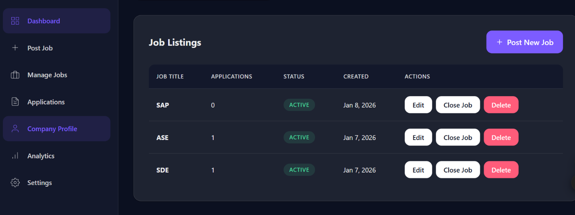
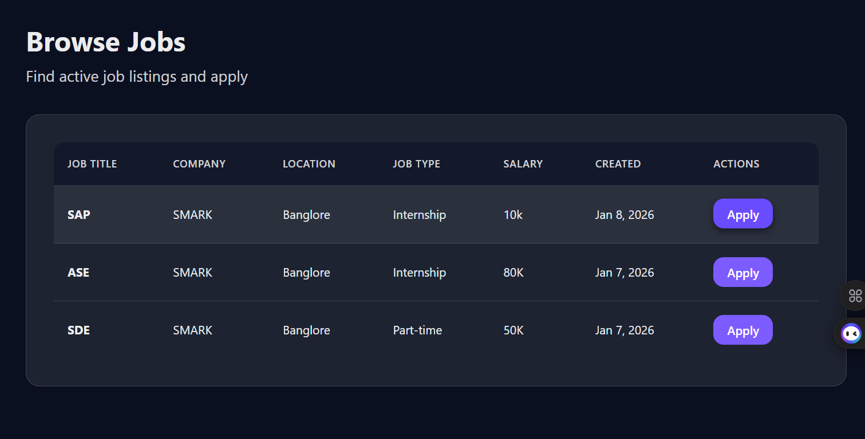

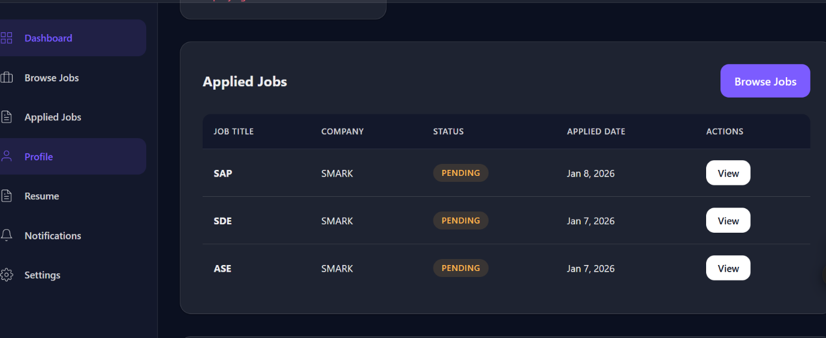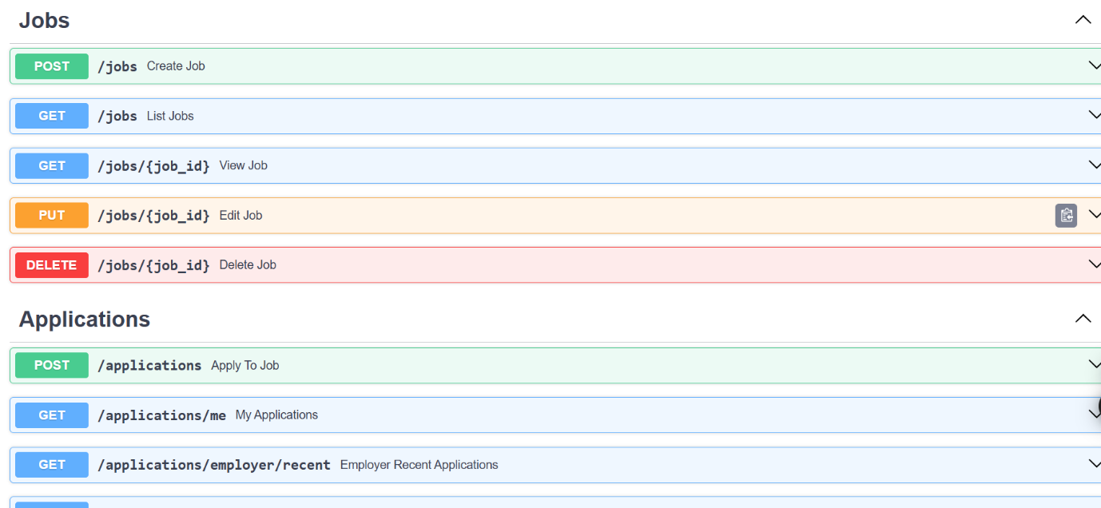

3. System Performance & Reliability
The system demonstrates reliable performance under normal usage conditions.
- Fast response time for job search and application submission
- Asynchronous backend operations improve performance
- Secure authentication ensures data privacy
- Database transactions are handled efficiently
- Error handling prevents system crashes and data inconsistency
The application remained stable throughout testing, with no major failures during execution.

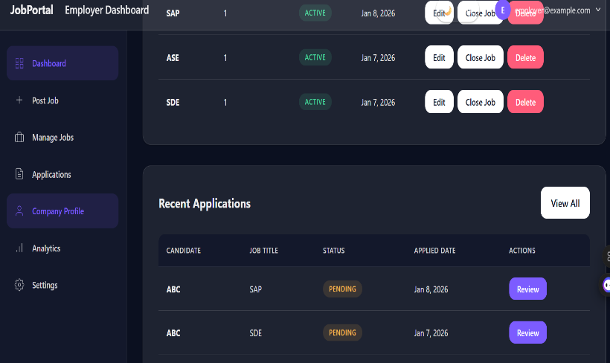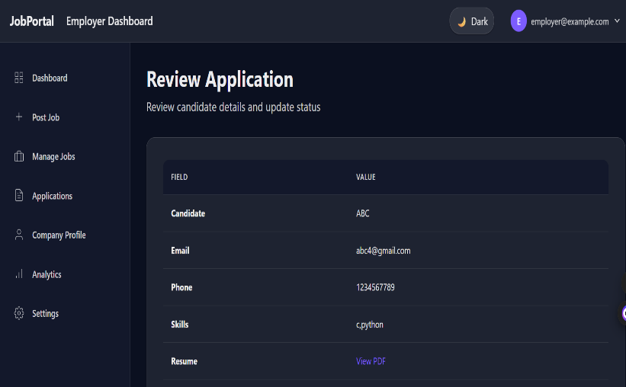
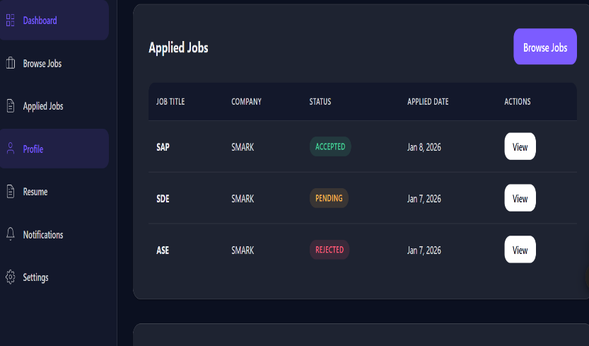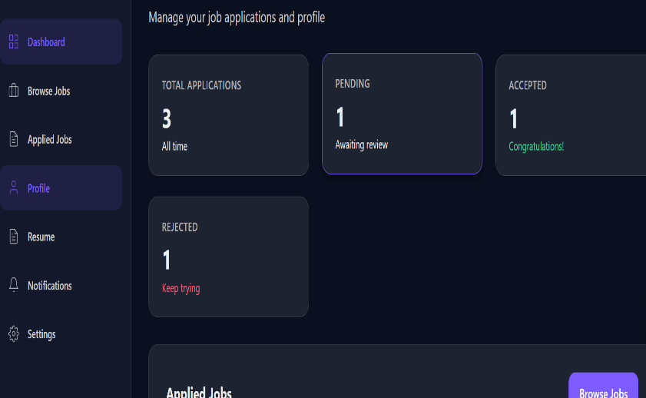

CONCLUSION

The Careermindr - Job Portal System was successfully designed and developed as part of the one-month online remote project provided by Amdox Technologies. The project effectively achieved its objective of creating a secure, scalable, and user-friendly platform that bridges the gap between job seekers and employers.
The system supports essential recruitment functionalities such as user authentication, role-based dashboards, job listing management, job search, and application tracking. By implementing modern backend technologies and a structured database design, the application ensures reliable performance, data security, and ease of maintenance.
Through this project, the team gained valuable hands-on experience in full-stack web development, collaborative remote work, and real-world software engineering practices. The modular architecture allows the system to be easily enhanced with advanced features such as recommendation systems, resume analytics, and notification services in the future.
Overall, the project stands as a successful implementation of an intelligent job portal system that meets industry standards and fulfills the requirements defined by Amdox, while also serving as a strong foundation for future improvements and scalability.

TEAM CONTRIBUTIONS
Team Member Name | Module / Responsibility | Key Contributions
Vijay Athithyaa G V | Authentication & Profile Management | Implemented user registration and login functionality, handled secure authentication flow, and developed profile management features for both job seekers and employers.
Neha K S | Job Listing Module | Designed and implemented job listing creation, update, and deletion functionality, managed job data storage, and ensured seamless integration with dashboards.
Pranali Prakash Pisal | Job Application Module | Developed job application workflow, enabled job seekers to apply for jobs, managed application data, and assisted in testing application status tracking.
Mukesh Balaji M P | Job Search Module | Implemented job search functionality, applied filters such as job type and location, optimized search queries, and ensured accurate job listing results.

References
- FastAPI Documentation. FastAPI: Modern, Fast Web Framework for Building APIs with Python.
https://fastapi.tiangolo.com/
- Python Software Foundation. Python Programming Language Documentation.
https://docs.python.org/3/
- PostgreSQL Global Development Group. PostgreSQL Official Documentation.
https://www.postgresql.org/docs/
- SQLAlchemy Documentation. SQLAlchemy ORM and Database Toolkit.
https://docs.sqlalchemy.org/
- JWT.io. JSON Web Token Introduction and Usage.
https://jwt.io/introduction
- Mozilla Developer Network (MDN). HTML, CSS, and JavaScript Documentation.
https://developer.mozilla.org/
- GitHub Docs. Version Control and Collaboration Using Git.
https://docs.github.com/
- Uvicorn Documentation. ASGI Server for Python.
https://www.uvicorn.org/

